**TASK # 1: Develop , test and validate HTML document that collects the following information from the user :**

**last name , first name ,midle initial, age(restricted to be greater than 17), and weight restricted to the**

**range from 80 to 300). You must have event handlers for the form elements that collect this**

**information. These handlers must check the input data for correctness. Message in alert windows**

**must be producedwhen errors are detected.**

**Code:**

**HTML:**

<!DOCTYPE html>

<html>

<head>

<title></title>

<meta charset="utf-8" />

</head>

<body>

<form name="myForm" onsubmit="return (validate());">

<table border="1">

<tr>

<td>

First Name

</td>

<td>

<input type="text" name="firstName" />

</td>

</tr>

<tr>

<td>

Last Name

</td>

<td>

<input type="text" name="lastName" />

</td>

</tr>

<tr>

<td>

Age

</td>

<td>

<input type="text" name="age" />

</td>

</tr>

<tr>

<td>

Weight

</td>

<td>

<input type="text" name="weight" />

</td>

</tr>

<tr>

<td colspan="2">

<button style="display:block;margin:auto;" value="button" name="myButton">Submit</button>

</td>

</tr>

</table>

</form>

<script>

function validate() {

firstName = document.myForm.firstName.value;

lastName = document.myForm.lastName.value;

age = document.myForm.age.value;

weight = document.myForm.weight.value;

if (age < 17) {

alert("age should be greater than 17");

}

if(weight>300 || weight <80){

alert("Invalid weight");

}

}

</script>

</body>

</html>

**Output :**

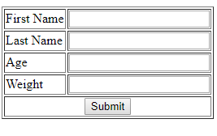

**TASK # 2: Design a shipment form used in E-commerce web sites with compulsory fields marked with red \***

**(star). Use appropriate validations for all the fields. Submit the form only if all the compulsory fields**

**are filled up and the values are valid, otherwise print the appropriate message and send the focus to**

**appropriate field.**

**CODE :**

<!DOCTYPE html>

<head>

<style>

.main{

position:fixed;

top:0;

left:0;

width:100%;

height:100%;

}

.formdiv{

width: 25%;

height: 50%;

top: 25%;

margin: 0 auto;

position: relative;

background:orange;

}

input:focus {

background-color: yellow;

}

input{

width: 100% ;

}

.heading1{

text-align: center;

}

</style>

</head>

<body>

<div class="main">

<div class="formdiv">

<h1 class="heading1"> Shipment Form</h1>

<form action="/action_page.php">

<input placeholder="Firstname" type="text" name="firstname" required>

<br>

<br>

<br>

<input placeholder="LastName" type="text" name="lastname" required><br>

<br>

<br>

<input placeholder="Address" type="text" name="lastname" required><br>

<br>

<br>

<input type="submit" value="Submit">

</form>

</div>

</div>

</body>

</html>

**Output:**

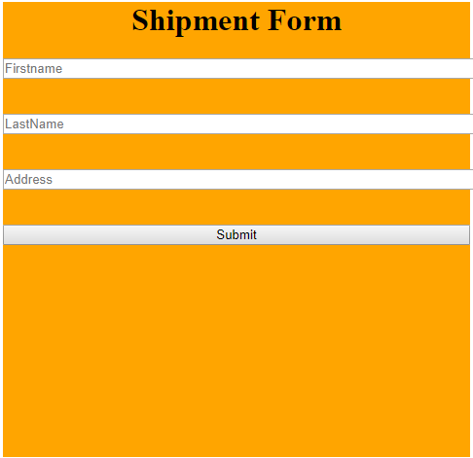

**TASK # 3 : Create a HTML document that collects information for astudent course registeration form for Bahria**

**university. Take input following fields . write regular expressions for them and validate the input of**

**the fields.**

**• Registeration number**

**• Current semester**

**• Enrolment number**

**• Course code**

**• Show alert msg on wrong input.**

**Code:**

<!DOCTYPE html>

<head>

<style>

.main{

position:fixed;

top:0;

left:0;

width:100%;

height:100%;

}

.formdiv{

width: 25%;

height: 50%;

top: 25%;

margin: 0 auto;

position: relative;

background:orange;

}

input:focus {

background-color: yellow;

}

input{

width: 100% ;

}

.heading1{

text-align: center;

}

</style>

</head>

<body>

<div class="main">

<div class="formdiv">

<h1 class="heading1"> Course registeration Form</h1>

<form action="#">

<input placeholder="Registeration number" id="regno" type="text" name="regno" required>

<br>

<br>

<br>

<input placeholder="Enrollment Number" id="enrollno" type="text" name="enrollno" required><br>

<br>

<br>

<select>

<option value="first">first</option>

<option value="second">second</option>

<option value="third">third</option>

<option value="fourth">fourth</option>

<option value="fifth">fifth</option>

<option value="sixth">sixth</option>

<option value="seventh">seventh</option>

<option value="eighth">eighth</option>

</select> <br>

<br>

<input placeholder="Course code" id="coursecode" type="text" name="coursecode" required><br>

<br>

<br>

<button onclick="myvalidate(document.getElementById('regno'),document.getElementById('coursecode'),document.getElementById('enrollno'))">Submit</button>

</form>

</div>

</div>

<script>

function myvalidate(input,coursecode,enrollno){

var numbers=/^[0-9]+$/;

var alphanum=/^[a-zA-Z0-9]+$/;

if((!input.value.match(numbers)) || (input.value.toString().length>6)){

alert("wrong registeration number");

}

if((!coursecode.value.match(alphanum)) || (coursecode.value.toString().length>6)){

alert("wrong coursecode ");

}

if((!enrollno.value.match(alphanum)) || (enrollno.value.toString().length>11)){

alert("wrong enrollment no");

}

}

</script>

</body>

</html>

**Output :**

